Q1) Explain DECIDE framework with necessary diagram and an example of the same
The DECIDE Framework is a systematic approach to conducting evaluations in Human-Computer Interaction (HCI). It helps ensure that evaluations are well-planned, goal-oriented, and effective in assessing usability or user experience.
DECIDE Framework Steps:
Determine the goals:
Define what you aim to achieve with the evaluation.
Example: Assess the usability of a new mobile banking app.
Explore the questions:
Formulate specific questions to answer.
Example: How easily can users navigate to check their account balance?
Choose the evaluation methods:
Decide on techniques (e.g., user testing, surveys, or interviews).
Example: Conduct usability testing with think-aloud protocols.
Identify the practical issues:
Address logistical details like participant recruitment, ethical concerns, and resources.
Example: Recruit 10 participants and ensure consent forms are signed.
Decide how to deal with the ethical issues:
Protect participants' data and ensure no harm or discomfort.
Example: Keep test results confidential and offer participants the right to withdraw
Evaluate, interpret, and present the data:
Analyze the data and draw conclusions.
Example: Summarize findings in a report and identify navigation issues.
For diagram – in flowchart manner arrange all the points
Example of the DECIDE Framework
Scenario: Evaluating an e-learning platform.
Determine Goals: Evaluate the platform's usability and effectiveness in enhancing learning outcomes.
Explore Questions:
Can users easily locate courses?
Is the interface intuitive for new users?
How satisfied are users with the content layout?
Choose Methods: Use usability testing, questionnaires, and interviews.
Identify Practical Issues: Recruit 15 participants, allocate 2 hours for testing, and prepare devices.
Deal with Ethical Issues: Obtain informed consent and anonymize data.
Evaluate Data: Analyze results to identify issues like confusing navigation or slow response times.
-------------------------------------------------------------------------------------------------------------------------------------------------------------Q2) What are the goals of evaluation? Explain Cognitive walkthrough and heuristics evaluation technique in detail
Evaluation is the process of systematically assessing the usability, functionality, and effectiveness of an interactive system by gathering data from users, observing their behavior, and analyzing their feedback.
Goals of Evaluation in HCI
Evaluation in Human-Computer Interaction (HCI) aims to ensure systems are usable, efficient, and satisfying for users. Key goals include:
Identify Usability Issues:
Detect problems that hinder users from achieving their goals effectively.
Assess User Experience:
Evaluate how users feel when interacting with the system (e.g., satisfaction, frustration).
Verify Design Objectives:
Check if the system meets the intended design goals.
Enhance Product Quality:
Improve functionality, interface design, and overall performance.
Support Iterative Design:
Inform the redesign process to refine and improve the system.
Facilitate Decision-Making:
Provide insights to stakeholders for future development and implementation.
1. Cognitive Walkthrough
The Cognitive Walkthrough is a usability evaluation method focused on understanding a user’s thought process when interacting with a system. It assesses the learnability of an interface, especially for new users.
Steps of Cognitive Walkthrough:
Define user goals and tasks:
Identify tasks that users will attempt.
Describe the interface:
Detail all elements the user interacts with.
Define the user profile:
Focus on first-time users with limited experience.
Simulate the user's thought process:
Ask four key questions for each task:
Will the user try to achieve the right effect?
Will the user notice the correct control/interface element?
Will the user associate the control with the desired effect?
If the action is correct, will the user receive clear feedback?
Document issues:
Identify steps where the user may face confusion or errors.
Example:
Scenario: Evaluating a mobile app's login process.
Task:
Log in using email and password.
Simulate the user's experience by checking:
Can users locate the "Login" button?
Will users know to click on the email field first?
Is feedback provided if the email format is incorrect?
2. Heuristic Evaluation
The Heuristic Evaluation is a usability inspection method where evaluators assess an interface based on predefined usability principles (heuristics). It is cost-effective and identifies usability problems early.
Steps of Heuristic Evaluation:
Select evaluators:
Typically, 3-5 usability experts.
Prepare heuristics:
Use established principles, like Nielsen’s 10 Usability Heuristics:
Visibility of system status.
Match between system and real-world.
User control and freedom.
Consistency and standards, etc.
Evaluate the interface:
Each evaluator reviews the interface independently.
Document findings:
Note any violations of heuristics.
Prioritize issues:
Rank issues based on severity (e.g., minor, major, critical).
Suggest improvements:
Provide actionable recommendations.
Example:
Scenario: Evaluating an e-commerce website.
Issues Found:
Lack of clear feedback after adding items to the cart (violates visibility of system status).
Confusing labels like “Checkout Now” vs. “Proceed to Payment” (violates consistency).

Q3)User Interface Management System (UIMS)
A User Interface Management System (UIMS) is a framework or software layer that helps in designing, implementing, and managing user interfaces (UIs) of interactive computer systems. It separates the UI logic from the application logic, allowing developers to focus on the interface without affecting the underlying functionality.
Objectives of UIMS
Separation of Concerns: Decouples the user interface from the application logic.
Reusability: Promotes the reuse of UI components across different applications.
Consistency: Ensures uniformity in interface design.
Flexibility and Maintainability: Simplifies updates and modifications to the interface.
Support for Multiple Modalities: Manages inputs from devices like keyboards, mice, and touchscreens.
Enhanced Productivity: Speeds up development through reusable templates and tools.
Architecture of UIMS
The architecture of UIMS typically follows a modular structure that separates different concerns of the UI and its interaction with the system.
Key Components
Presentation Layer:
Handles the layout, visual design, and user interaction.
Example: Buttons, menus, forms, and windows.
Dialogue Controller:
Manages the flow of interaction between the user and the application.
Example: Defines sequences of events, such as what happens when a button is clicked.
Application Logic:
Contains the core functionality and business logic of the application.
Example: Processes calculations, database queries, or system commands.
Interaction Toolkit:
Provides tools and widgets for building the UI.
Example: Libraries for buttons, sliders, and input fields.
Device Interface:
Communicates with input and output hardware devices.
Example: Handles input from a mouse or keyboard and output to a display or printer.
Data Model:
Represents the application's data and its state.
Example: The database or in-memory data structures used to store user data.
Working of UIMS
User Interaction:
The user interacts with the Presentation Layer using input devices.
Event Handling:
The Dialogue Controller processes user actions and determines the response.
Core Processing:
The Application Logic performs the required operations based on user input.
Feedback:
Results are sent back to the user via the Presentation Layer.
Advantages of UIMS
Improved Modularity
Enhanced Development Speed
Cross-Platform Support
Consistency
Example: GUI in Banking System
In a banking system:
Presentation Layer: Displays account information and transaction history.
Dialogue Controller: Handles button clicks, such as "Transfer Funds."
Application Logic: Executes the transfer operation.
Data Model: Updates the user's account balance in the database.
Q4) UIMS Conceptual Architecture
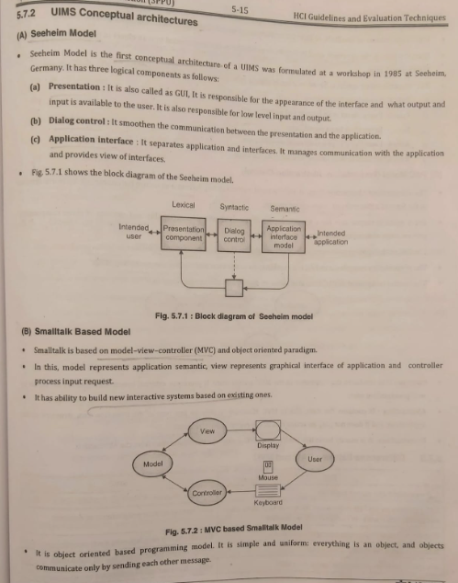
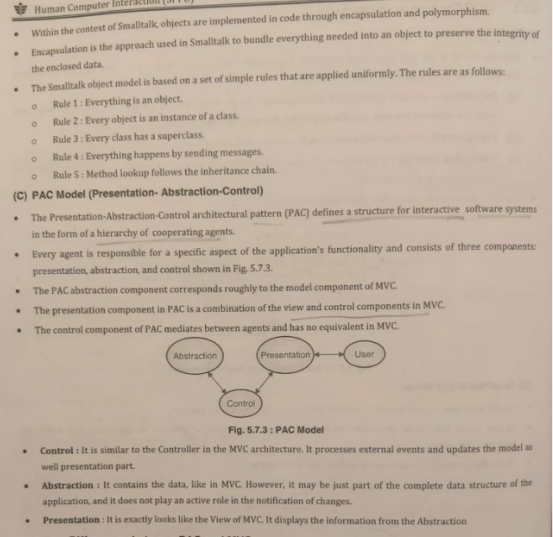
Q5) TOOLKITS AND USABILITY TESTING
i) Toolkits
Toolkits are software libraries or frameworks that provide reusable components, functions, and tools for developing user interfaces (UI) and applications. They simplify UI development by abstracting complex functionalities and offering pre-built widgets and interaction models.
Features of Toolkits:
Pre-Built Components: Includes buttons, text fields, menus, sliders, and more.
Cross-Platform Support: Many toolkits work across different operating systems.
Event Handling: Provides mechanisms for managing user interactions like clicks or keystrokes.
Customization: Allows developers to modify components to suit specific needs.
Integration: Works seamlessly with other programming libraries or frameworks.
Examples of Toolkits:
Tkinter (Python): Simple GUI toolkit for Python applications.
Qt (C++): Advanced cross-platform toolkit.
JavaFX (Java): Toolkit for rich graphical interfaces.
ReactJS (JavaScript): For creating component-based UIs for web applications.
Advantages:
Speeds up development.
Reduces coding effort by reusing components.
Ensures consistency in design.
Disadvantages:
Limited flexibility for highly customized designs.
Dependence on toolkit features, which may be restrictive.
ii) Usability Testing
Usability testing is a method used to evaluate how effectively users can interact with a system or product. It identifies issues in design, ease of use, and user satisfaction by observing real users performing tasks.
Steps in Usability Testing:
1)Plan the Test:
Define objectives and key tasks to evaluate.
Select target user profiles.
2)Recruit Participants:
Typically 5-10 users representing the target audience.
3)Conduct the Test:
Users perform specific tasks while observers note difficulties and behavior.
4)Analyze Results:
Identify usability issues, error patterns, and areas of confusion.
5)Suggest Improvements:
Provide recommendations for enhancing usability.
Benefits of Usability Testing:
Improves user satisfaction by addressing pain points.
Reduces development costs by catching issues early.
Enhances productivity and efficiency for users.
Types of Usability Testing:
Moderated Testing: Conducted in the presence of an evaluator to guide users.
Unmoderated Testing: Users perform tasks independently, often remotely.
A/B Testing: Compares two versions of an interface to determine which performs better.
Example: Scenario: Testing the usability of a food delivery app.
Objective: Ensure users can place an order within 5 minutes.
Tasks:
Search for a restaurant.
Select a meal.
Add it to the cart and proceed to payment.
Findings:
Users struggled to locate the "Add to Cart" button.
Payment options were unclear.
Recommendations:
Redesign the "Add to Cart" button to be more prominent.
Simplify the payment page layout.
-------------------------------------------------------------------------------------------------------------------------------------------------------------
Q6) Evaluation ? Categories of Evaluation , ExPLAIN ANY ONE CATEGORY
Categories of Evaluation
Evaluation methods can be broadly classified into two categories:
Analytical Evaluation (without user involvement).
Empirical Evaluation (with user involvement).
Detailed Explanation of Analytical Evaluation (Category)
Analytical Evaluation is conducted by usability experts or designers without involving real users. It relies on theoretical models, guidelines, and heuristics to predict usability issues.
Types of Analytical Evaluation
1.Heuristic Evaluation:
Evaluators check the system against a set of usability principles or heuristics (e.g., Nielsen's heuristics).
Example Heuristics: Consistency, error prevention, and feedback.
Process:
Usability experts inspect the interface.
Identify violations of heuristics.
Rate the severity of each problem.
2.Cognitive Walkthrough:
Focuses on how easily a new user can perform tasks.
Evaluators step through tasks to identify areas of confusion.
Process:
Identify tasks for evaluation.
Define steps a user will take to complete those tasks.
Check whether the user can understand and execute each step.
Example of Heuristic Evaluation
Scenario: Evaluating an e-commerce website.
Issue: Users struggle to locate the search bar.
Heuristic Violated: Visibility of system status.
Recommendation: Make the search bar more prominent by increasing its size and adding placeholder text like "Search for products."

